Automated Election System

Hipolito, Jovellano, Pachico

Abstract

The Philippines has been adopting the Automated Election System after years of adhering and relying on the Manual Voting System. It has been proven that the process became more efficient and generates results in a lesser time frame. However, complications are still evident in present time. For instance, electoral fraud still continues to remain through the existence of memory cards especially for the counting/transmission of election returns. There are many factors to consider in determining the causes of result manipulation that includes the humans accessing the system extensively. A physical object like the memory card is easy to exploit though many seem to think that transmitting/counting the results using memory cards are reliable and dependable. This study aims to produce a new system in which transmitting and counting of the votes does not require physical contact with other entities besides the system itself.

List of Figures, List of Tables, List of Notations

1. Event Table
2. Context Diagram
3. Data Flow Diagram
4. Use Case Diagram
5. Activity Diagram
6. Object Diagram
7. Class Diagram
8. Communication Diagram
9. State Diagram
10. Timing Diagram
11. Sequence Diagram
12. Component Diagram
13. Composite Diagram
14. Interaction Overview Diagram
15. Package Diagram
16. Deployment Diagram

Introduction

**Background of the Problem**

After years of having a manual voting system, the Philippines have finally adopted to the computerized voting in 2010. The Automated Election System (AES) was mandated by Republic Act No. 9369 which is the Amended Elections Automation Law. The law stated that there would be a paper-based election system defined as “a type of automated election system that uses paper ballots, records, and counts votes, tabulates, consolidates, canvasses and transmits electronically the results of the votes count” (Angkaya, 2011). Given this provision, the voters would need to shade the oval that corresponds to the chosen candidate using a pencil on an official scanned paper ballot. This makes the Philippine AES not 100% automated for it still uses paper ballots that would later on be scanned by the Precinct Count Optical Scan (PCOS) machine to electronically count the votes.

By standards, the new technology should be significantly faster and more accessible for all voters. However, the first automated election last May 10, 2010 inevitably had errors in the compact flash cards containing the list of voters and candidates, delays in transmitting results to the canvassing centers, and failure of built-it ultraviolet mark readers in the PCOS machines to read the security marks on the ballots (Atienze, 2016). The same concern was raised by various poll watchdogs and IT experts when KontraDaya representative stated that in the 2013 election, 18,000 of the 79,000 PCOS machines failed to transmit results on the Election Day. Additionally, he noted that no credible audit of the source code, the software that runs the PCOS machines, was ever provided (Herrera, 2014). Despite paying billions of pesos in 2009 to automate the election, the COMELEC were still criticized for the poor performance of the PCOS machines and the persistent occurrence of electoral fraud in different precincts all over the country.

Electoral fraud is defined as the illegal interference with the processes of an election which affect vote counts. The most common forms of electoral fraud happening in the current AES are the following: disenfranchisement of voters, misleading/confusing ballot design, and tampering with the election results. The first form of electoral fraud occurs when a group or an individual fail to cast their vote due to invalidation of ballots or PCOS machines. The second act, which is confusing ballot design, transpires when the ballot design itself encourages or discourages particular party or candidate. The official ballot used the English language in the previous elections which considered it not voter friendly especially for the citizens who do not understand the said language. Only the part of how to vote is written in the Filipino language. The rest are all in English. This can be considered a huge disadvantage for those voters who have limited literacy in the language. Moreover, the font size of 10 is too small for impaired citizens particularly for the senior citizens. Last but not the least which is the main concern of the voting public is the issue on tampering with the election result. Electoral fraud can also be committed in a more sophisticated approach like, of course, computer hacking. According to the Supreme Court, the possibility of system hacking with AES is very slim for the PCOS machines are only online for one to two minutes which makes it almost impossible to hack. However, the municipal, provincial and national hubs that will receive the transmission of election results do not have the same mechanism. These hubs would be online for a prolonged period of time which makes it very exposed ad vulnerable to hacking all throughout that time it was online. Furthermore, the memory cards used during the elections are not read-only, in contrary to what the Supreme Court have stated before. In fact, the data from the ballots cast along with the final count of the votes to the candidates will be stored in the same memory card. This is not possible for a read-only memory card making it a read-write capable (Vitangcol III, 2010). This only means that the memory card can indeed by deleted, modified, and manipulated.

The current technology has various issues that the study would want to resolve at the end of the project. It is important for the administrators to resolve the issues at hand to have a fair and fruitful election. Conversely, if these problems continue to persist in the succeeding elections, it is expected for the Philippines to have an election that does not reflect the choice of every single Filipino voters which then leads to undeserving officials of the government being elected in the office. In order to develop a system that promotes efficiency and transparency, it is important that the researchers understand these problems first to determine the appropriate solutions and actions that should be taken to achieve their goals not only for the system but for the country as well.

**Statement of the Problem**

How can the Philippine election system prevent electoral fraud specifically for the counting of the votes?

**Objectives**

General Objectives

* To know the vital issues present in the casting to transmission of the votes
* To propose a system that would prevent electoral fraud in the counting of votes in the election system

Specific Objectives

* To develop a system that would transmit election returns without the need to import data from one physical memory card to another
* To design a database that would cater to the need of the proposed system

**Significance of the Study**

The findings of this research will benefit the following key players:

To the Filipino Citizens

This study will benefit the Filipino citizens for ensuring the security of the casted votes. Also, it would prevent malicious individuals from manipulating the votes. Although the nature of automation easily provoke fear to ignorance of using technology, this study will educate some of those users that still lack computer literacy foundation. Indeed education can bridge the existing gaps and even remove the unnecessary fear from automation. This will leave the citizens better equipped for the future of the Philippine automated election system.

To the COMELEC

This research would significantly contribute to the goal of the COMELEC to conduct a fair and transparent election. Considering the impact of the elections in the overall condition and future of the Philippines, it is important to make sure that the voters’ choice reflect the outcome of the election. To do that, the system should be able to prevent and mitigate electoral fraud while ensuring that the voters have casted their votes in a way that is convenient and voter-friendly. This study will aim to determine the most appropriate methods to achieve the kind of system that does not manipulate the vote of the people in any way through data gathering and research. In this manner, the people will be knowledgeable about how the system works and be informed and wise voters themselves.

To the Future Researchers

As the Philippines adjust to this kind of voting system, more and more developers would also contribute to the AES aspect of software development. In that case, the system that would be created can serve as a guide and inspiration for other developers who would want to pursue the prospect of automated election system too.

Scope and Limitation

The Automated Election System is said to be the system that needs to be improved and in order for this system to be developed there are parts that has to be modified. This system will only focus on the casting and transmission part of the voting system which means the counting and accumulation of votes, storage of votes, and authentication of votes by having digital signature before the transmission are also included. Unfortunately, the Automated Election System is a huge system that is why the study will no longer discuss the processes aside from the casting to transmission part of the voting system to be able to concentrate on the said scope and give solution to the statement of the problem.

Review of Related Literature

**Related Literature**

**Automated Election Law**

According to the Commission on Elections, “The Republic Act No. 9369 is an act authorizing the Commission on Elections to use an automated election system in… subsequent national and local electoral exercises to encourage transparency, credibility, fairness and accuracy of elections…”. (Retrieved on April 10, 2016/ <http://www.comelec.gov.ph/?r=References/RelatedLaws/ElectionLaws/AutomatedElection/RA9369>).

One section of the law states that the minimum conditions provided should be met by the automated election system which includes the granting of Voter Verified Paper Audit Trail. It allows the voters to check if the votes were cast precisely and to detect the possibility of having electoral fraud or system malfunction. Also, the law requires the system to have documents that can verify the correctness of the reported results that are provided by the system itself. Moreover, The Commission on Election (Comelec) is the institution liable for implementing and assuring that the system’s minimum conditions are met. (Atienza, 2016, par. 2-4).

**Description of the System**

Before officially starting the elections, there are preparations made in order to achieve a well-prepared and organized Automated Election System (AES). The very superior part of the AES is the Election Management System (EMS). Its main job is to prepare the automation polls and to manage pre-election data that includes the number of registered voters, candidate details and other information that is essential for the election. The preparation of ballots and the file configurations needed in the Precinct Count Optical Scan (PCOS) machines are also under the jurisdiction of the EMS. (Bueza, 2015, par. 4-8). In the Philippine setting, the automated election system relies on the PCOS machines. However, a claim by Ellorin (2013) suggests that the Philippine elections is not 100% automated because paper ballots are still being utilized up to present time. (par. 3).

In order to successfully cast the votes, there is a series of steps that needs to be followed. First, a voter manually fills out a ballot by properly darkening the oval beside the names of the candidates they prefer. After selecting and shading the ballot, the voter must insert the ballot into the PCOS machine. Based on the readings of the shaded oval, the machine will then record and store the votes cast by the voters in an internal memory. In case of data loss, a removable memory card is used to back up the results and applications in the PCOS machine. The security features of the machine is taken into consideration to prevent fraud and malicious attacks aiming to sabotage the results of the automated election system. Each machine is equipped with a unique security key and verification PIN code. Before starting the elections, the Board of Election Inspectors is given the task to input the key and code for authentication. After the PIN is entered, the machine’s initialization report is generated. It should indicate that there are currently zero entries which means that the machine has no data yet. When the voting starts, the LCD screen of the machine will show the continuing count of the number of votes submitted. At the end of the voting period, the Board of Election Inspectors will commence the digital counting process and prepare the printing of Election Returns. In transmitting the results, the ER is sent to the Comelec hub and the PCOS will be able to print copies of the ER for the national and local positions. Additionally, a statistical report and log is produced for supplementary documentation. (Ellorin, 2013, par. 1-19).

**Issues of the Current Technology**

Smartmatic is a corporation that specializes in the design of complex “purpose-specific” technologies and is known to provide and create voting systems. The Precinct Count Optical Scan (PCOS) that the Comelec uses for the national and local electoral practices were purchased from Smartmatic for a large sum of money. However, despite its marketing value many experts claimed and observed various defects in the PCOS machine. Renato Reyes, a KontraDaya advocate, said that during the 2013 elections a large number of PCOS machines failed to transmit its results. “No real and credible review or audit of the source code, the software that runs the PCOS machines, was ever done”, added Reyes. The delayed consignment of the source code resulted from the fact that Dominion, the owner of the source code, and Smartmatic had already ended their legal agreements. The source code consists of the sets of instructions for the PCOS machine. Due to the ended agreement many controversies against Smartmatic began to surface which includes there right to sell the PCOS machines. Another problem that has been noted is the ability of the machine to display and to provide assurance that the votes were properly and accurately recorded. (Automated Failures, 2014).

A test conducted by SysTest Labs discovered that there were many programming errors in Smartmatic’s programs that possibly caused the technical errors during the elections. Evidently, there were a significant number of tabulation errors displayed in the public website of Comelec because of the system flaw. The SysTest Labs is the institution responsible for testing the machine’s operations in accordance with the RA-9369. However, they failed to properly conduct the tests resulting to uncertainties with regards to the machine’s ability to operate. The most questionable error reported was the processing of the database transactions. Such errors can cause the system to stop running or to produce wrong results. According to the Comelec, transmissions of votes were done via the internet to their corresponding destinations. If the internet transmission fails, then the election returns (ER) or vote results are hand-carried by the Board of Election Inspectors (BEI) to the appropriate canvassing centers. Moreover, if partial failure occurs then the BEI will fail to notice that there is a failure in transmitting the votes thus considering the error successful. This is commonly observed during the transmission to the Consolidation Canvassing System (CCS) that is divided into three namely, the municipal, provincial and Comelec. (Manalastas, 2010, pp.1-5).

A study by Manalastas (2012) on the Comelec public access website revealed that there is evidently a large scale of transmission errors. Computer programs were used to count the number of precincts that did not have ERs. From a total of 76, 472 precincts only 67,162 or 87.8% has the normal number of ERs. On the other hand, 8,939 or 11.7% failed to transmit their accumulated votes and 371 or 0.5% of the precincts recorded few voters. However, in those 67,162 precincts that had normal transmission 25,888 were reported to have missing data. (pp. 1-5).

**Automation and Electoral Fraud**

According to Vitangcol III (2010), “Electronic voting is a general term encompassing several different types of voting, embracing both electronic means of casting a vote and electronic means of counting votes”. He claimed that the Philippines’ AES is practicing the “document ballot voting system”, wherein paper ballots are marked by hand but tallied electronically. Additionally, he quoted that “One of the basic democratic principles of election is ‘voting in secret and counting in public’”. However, the use of PCOS machines in counting electoral votes cancels out the second principle. (Retrieved on April 10, 2016/ <http://www.philstar.com/starweek-magazine/564937/look-automation-and-electoral-fraud>).

The transparency of vote count is for the right of the people to view important information. The 1987 Constitution states that:

*“The right of the people to information on matters of public concern shall be recognized. Access to official records, and to documents and papers pertaining to official acts, transactions, or decisions, as well as to government research data used as basis for policy development, shall be afforded the citizen, subject to such limitations as may be provided by law. “*

Additionally, Article 2 Section 28 states that:

*“Subject to reasonable conditions prescribed by law, the State adopts and implements a policy of full public disclosure of all its transactions involving public interest. Therefore, it is very clear from the Constitution that transparency is an important pillar of Philippine democracy. “*

(Citizen Reform Agenda 2010: Agenda on Anti-Corruption For Candidates and Political Parties of the Upcoming 2010 Elections, 2010, p.5)

Furthermore, there are problems that may occur during the elections and one example is electoral fraud. It is defined as an illegal obstruction with the entire process of the election that greatly affects the vote counts. There are many forms of electoral fraud as mentioned by Vitangcol III (2010) that negatively impacts the view of the citizens towards the credibility and validity of the PCOS machine. First, the disenfranchisement of voters which is the act of accidentally or intentionally making it difficult for legitimate voters to cast their votes. This can be done in many possible ways like switching the ballots to be delivered to the precincts or the tampering of the bar code present in the ballot in order to sabotage the votes of others. Next, confusing ballot design may affect the minds of the voters when casting their votes. The design of the ballot is important because a study shows that the first candidate’s name displayed in the ballot can accumulate an additional three percent of the total votes cast in their favor. The current ballot design is said to be inconvenient for the voters specifically the visually impaired merely because of the small font size. Moreover, the predominant use of the English language in the ballot and the placing of the oval to be shaded also adds confusion for some voters particularly those who have lower literacy. Confusing ballot design and disenfranchisement of voters may result to vote padding or vote shaving. Another form of fraud is the tampering of election results. Major technical issues are still left unresolved. For instance, the vulnerability of the machine to hackers because of poor security architecture design. A spokesperson of the Comelec stated, “I am not saying that the system cannot be hacked. No system is 100 percent hack-proof. I am just saying that we have made sure that the system will not be hacked”. They further claimed that the possibility of hacking the PCOS system is very slim because of the tiny span of online activity being done. However, there is no assurance that the other canvassing centers are also online for a short span of time. Hackers are known to be motivated by challenges that lets them develop systems that can paralyze or halt activities in another system. In reality, the institutions responsible in handing the AES do not have an effective security management to protect the important data being transmitted and collected from these hackers. (Retrieved on April 10, 2016/ <http://www.philstar.com/starweek-magazine/564937/look-automation-and-electoral-fraud>).

A result of the study conducted by Manuel L. Calimlim stated that, based from expert’s analysis and the key players’ interview that are associated with the automated election system the IT related factors contributing to awareness of the people with regards to electoral fraud are the PCOS machine glitch, faulty CF cards, data transmission, inconsistencies in audit logs, absence of digital signature resulting to concerns mainly on security, and unavailability of the source code making it impossible to undergo inspection. (Preliminary Findings on IT Related Factors That Contribute to Public Perceptions of Election Fraud in the Automated Election System in the Philippines, pp.10-15).

**Technology Assessment**

There are many areas that needs to be taken into consideration to fully implement the use of an online platform on the election system in the Philippines. The use of AES has its advantages and disadvantages.

It is already given that in order to conduct an automated election system there should be the availability of computers and other devices that are used as a medium during the elections. Although it can cost a large amount of money, it can still cut cost on other expenses like the labor cost. It can be a good investment considering the long term returns that is generated. Hardware and software investments and training for electoral workers should be taken into account. With the implementation of AES it is expected to provide efficient processing of tasks and results. Compared to voting manually, automated system has its perks. Instead of manually counting votes that were submitted the system will automatically count votes faster and accurately without the need of human intervention. The system’s mechanism reduces the probability of having errors due to fraud and tampering. Also, improved ability to identify and prevent frauds is possible. The system is equipped with encryption algorithms to store and transmit voted from the machine to the tabulation centers setting the integrity of the elections higher. On the other hand, a disadvantage of the AES is its vulnerability when people starts to enter the system without permission. Angkaya (2011) said, “Hackers are the number one enemy of this system”. Additionally, they try to manipulate computer programs in any possible way. Technology has its weakness and no system is 100% fool proof.

There is an undergoing debate about the feasibility of having an automated election in the Philippines. For the past years, Filipinos were capable of voting even those who are illiterate. With proper technology and mechanisms there is a chance that the election system of the Philippines would be purely automated. However, problems may occur along the way. In conducting an automated system, electricity is an important factor. Some rural areas are still having problem with the adequate amount of supply of electricity. Also, a number of personnel is expected to be deployed all around the country in order to troubleshoot and install the system. Senator Gordon stated that the automated elections would be possible if there would be a national ID system based on biometrics that the voters will provide. A check and balance is created because the system is not fool proof making it vulnerable to frauds. The presence of the Voter Verifiable Paper Audit Trails ensures the credibility and security of the votes being submitted in the machine. Lastly, protection of the source code is a priority to avoid hackers from entering the system. (Angkaya, 2010, chap. 4).

**Related Study**

**HALALAN**

University of the Philippines-Diliman implemented an automated voting for its local student university-wide elections. The voting system is known for its name “Halalan”. It does not utilize any paper ballots and is completely automated. The system was developed by the UP Linux Users Group (UnPLUG). The development started upon seeing the long paper ballots present in the university, thinking about the possibility of having an automated election system. The most notable feature of the Halalan system is the utilization of open source software. In order to run, it also needs network of computers connected to a web server and a database server. The voting that occurred in UP Diliman that started using the Halalan system begins in the following steps. A student goes to a precinct and presents his or her student ID. Once the ID is verified by the poll clerk, the voter is given a password from a listing of generated passwords. The voter goes to the computer and logs in his or her student number and the provided password. In the event of successfully logging in, an online ballot is displayed. The voter clicks on the boxed beside the names of the candidates and parties of their choice. The voter also has the choice to review his or her online ballot before submitting and confirming. The tallying of votes is continuously being accumulated until the end of the election. The Halalan system allows fast tabulation of votes if implemented accordingly. There is no need in spending hundreds of machined only designed for the purpose of reading a paper ballot. The expenses are devoted in buying personal computers or laptops that can be used for other purposes. The Halalan system may also encounter problems thus requiring a set of specific conditions. Highly stable computer network infrastructure should be present to ensure that all computers are connected to the central server at all times. There are also instances wherein the computer crashes and loses data. Another hurdle observed is the requirement that all voters must possess a degree of computer literacy in order to utilized electronic devices to its extent. (Reyes, 2010, par. 1-10).

**PATAS**

The Commission on Elections (Comelec) held a mock election that utilizes its proposed hybrid election system known as Precinct Automation Tallying System or PATAS at the Bacoor National High School. When using PATaS, voting is done manually and once the ballots are filled, it is then dropped in a ballot box. The counting of votes is also done manually by tallying. Augusto Lagman, an IT expert who proposed the idea of the hybrid election system, said that manual counting of the votes eliminates the possibility of result manipulation. "The problem with our current system — PCOS — is that right from the first step, we don't know if they (the votes) are being counted correctly”, Lagman added. Moreover, the hybrid system will help the people avoid accidental and intentional errors during transmission. It can also lessen the number of invalid or rejected votes as shown in a comparison between the 2013 automated election and the 2010 manual elections. In the 2013 automated elections, there were four million votes declared invalid compared to 2.1 million rejected votes in the 2010 manual elections. On the other hand, in PATaS the only automation part happens during the transmission of the total precinct count to the main servers. Lagman also claimed that by implementing the said system the government can cut down on the election system expenses. (Retrieved on April 12, 2016/ <http://cnnphilippines.com/news/2015/06/27/Commission-on-Elections-Comelec-holds-mock-elections-tests-hybrid-system.html>).

However, The Commission on Elections (Comelec) has rejected the proposal for a hybrid manual and automated election system in the 2016 national polls. Christian Robert Lim, Comelec's senior commissioner, cited the following reasons: the PATAS will cost more compared to the optical mark reader (OMR) system, whether it is leased or purchased; PATAS will require amendment of existing laws or enactment of new laws; PATAS is time-consuming, taxing and prone to human error; and the PATAS software still needs to be developed. (Retrieved on April 12, 2016/ <http://news.abs-cbn.com/nation/07/09/15/why-comelec-rejected-lagmans-hybrid-voting-system>).

**TAPAT**

TAPAT (Transparent Election System) was developed by Filipino IT group led by Edmundo Casiño, former president of the Philippine Computer Society (PCS), together with AES Watch. The alternative election system aims to make an election technology that is familiar to Filipino voters through the use of Lotto-type ballots. Moreover, a GPS-precinct-specific tablet will be used to scan and transmit the votes instead of the PCOS machines. However, after the said machine scans the ballot, it will issue a receipt called Voter Verified Paper Audit Trail (VVPAT) that allows voters to double-check the votes that the machine read and the voters casted. According to the developers, TAPAT will only take a maximum 3 minutes per voter and will only cost around a billion pesos. (<https://www.change.org/p/bill-endorsing-tapat-transparent-election-system-lotto-style-filipino-invented-automated-verifiable-voting-system-efficient-transparent-accountable-faster-better-and-cheaper-than-mexican-tech-smartmatic-pcos-for-2016-presidential-election?source_location=petitions_share_skip>).

In 2015, the Commission on Elections (COMELEC) tried the TAPAT voting system and was actually satisfied with the results except for the receipt issuance. They argued that this would only provoke voters to sell their votes but the IT group said that the VVPAT will be dropped by the voters together with the official ballots at the precinct. Due to time constraints however, the COMELEC thought it was a bit too late to integrate the system in the 2016 election but encouraged the developers to continue the improvements and tests for the promising election system. (<http://newsinfo.inquirer.net/706512/comelec-checks-out-tapat-voting-system>).

References

* Angkaya, S. (2011). *Automated Elections in the Philippines.* Retrieved on <http://iskwiki.upd.edu.ph/index.php/Online/Automated_Elections_in_the_Philippines#.VwpK2Gh97Dc>.
* Atienza, A. (2016). *IN THE KNOW: Automated Election Law.* Retrieved on <http://newsinfo.inquirer.net/767510/in-the-know-automated-election-law>.
* Bueza, M. (2015). *ow does the PH automated election system work?.* Retrieved on <http://www.rappler.com/newsbreak/iq/91663-philippine-automated-election-sytem-explained>.
* Calimlim, M. (2013). Preliminary Findings on IT Related Factors That Contribute to Public Perceptions of Election Fraud in the Automated Election System in the Philippines. *The Asia Pacific Chronicle,* 7 (1), 31.
* Ellorin, B. (2013). *Getting to know the country’s Automated Election System.* Retrieved on <http://newsinfo.inquirer.net/406147/getting-to-know-the-countrys-automated-election-system>.
* Manalastas, P. (2012). DEFECTS AND VULNERABILITIES OF THE SMARTMATIC 2010 AES. *Defects Vulnerabilities of SmartMaTic AES 2010.* 5.
* *Republic Act No. 9369.* Retrieved on <http://www.comelec.gov.ph/?r=References/RelatedLaws/ElectionLaws/AutomatedElection/RA9369>.
* Reyes, O. (2010). *How UP Diliman Implemented Its Own Automated Voting System.* Retrieved on <https://lawinnovations.wordpress.com/2010/02/18/halalandiliman/>.
* (2010). Agenda on Anti-Corruption For Candidates and Political Parties of the Upcoming 2010 Elections. *CITIZEN REFORM AGENDA 2010,* 9.
* (2014). *Automated Failures.* Retrieved on <http://www.manilatimes.net/automated-failures/132344/>.

Appendices

**Event Table**

|  |  |  |  |  |  |
| --- | --- | --- | --- | --- | --- |
| Event | Trigger | Source | Use Case | Response | Destination |
| Voter casts ballot | Accomplished ballot | Voter | Casts ballot | Casted ballot | System |
| System stores votes in the database | Scanned ballot | Ballot | Stores votes in the database | Stored votes in the database | Database |
| System prints receipt | Successfully stored votes | Database | Prints receipt | Printed receipt | Voter |
| BEI provides digital signature | End of voting period | BEI | Provides digital signature | Election return is incorporated with BEI’s digital signature | Election returns |
| BEI transmits Election Returns (ERs) to the Municipal Board of Canvassers | Completion of precinct votes | BEI | Transmits election returns to the Municipal Board of Canvassers | Transmitted ERs to the Municipal Board of Canvassers | Municipal BOC |
| Municipal Board of Canvassers (MBOC) transmits ERs to the Provincial Board of Canvassers | Completion of municipal election returns | MBOC | Transmits election returns to the Provincial Board of Canvassers | Transmitted ERs to the Provincial Board of Canvassers | Provincial BOC |
| Provincial Board of Canvassers (PBOC) transmits ERs to the Regional Board of Canvassers | Completion of provincial election returns | PBOC | Transmits election returns to Regional Board of Canvassers | Transmitted ERs to the Regional Board of Canvassers | Regional BOC |
| Regional Board of Canvassers (RBOC) transmits ERs to the National Board of Canvassers | Completion of regional election returns | RBOC | Transmits election returns to the National Board of Canvassers | Transmitted ERs to the National Board of Canvassers | National BOC |

**Context Diagram**

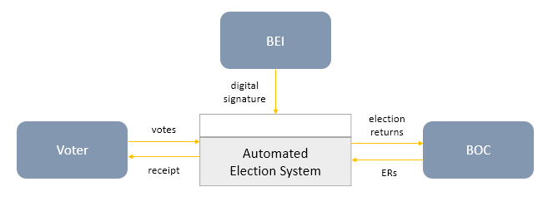

**Data Flow Diagram**

Diagram 0

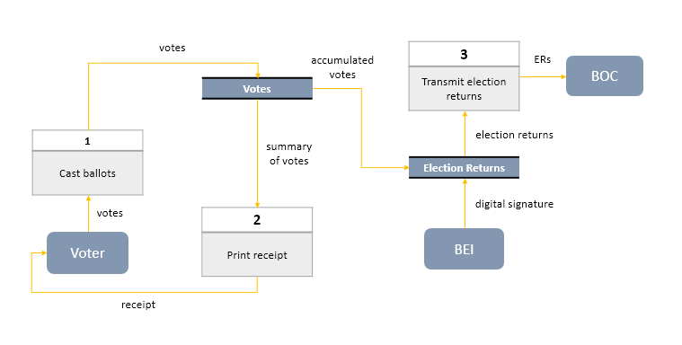

Diagram 1

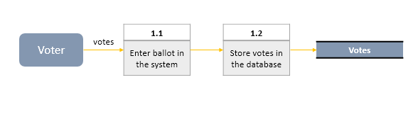

Diagram 3

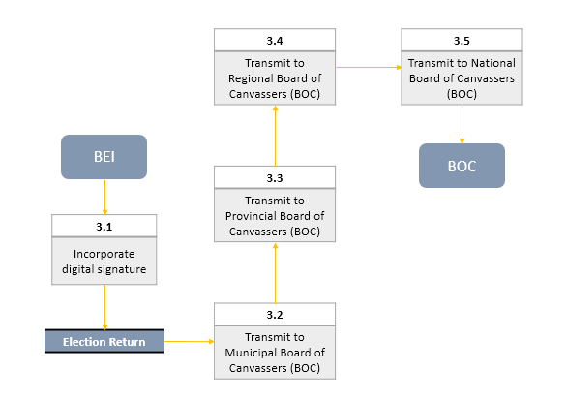

**Use Case Diagram**

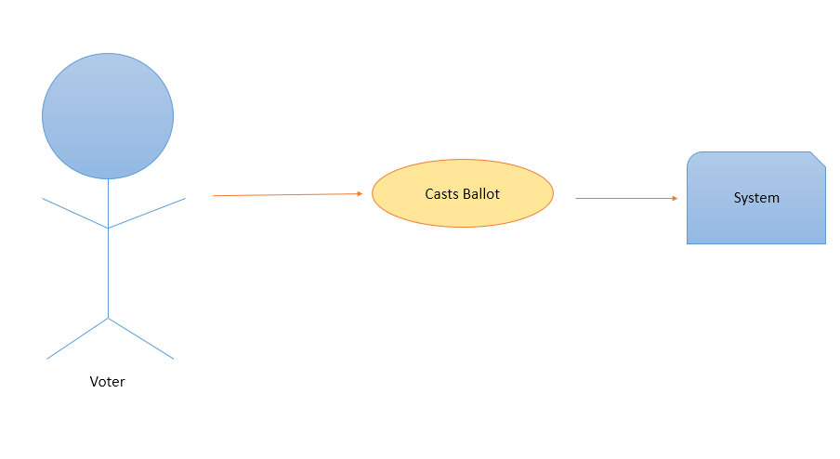

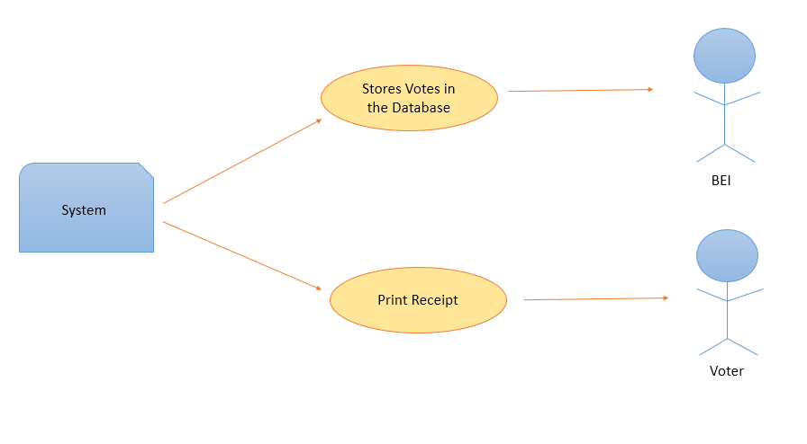

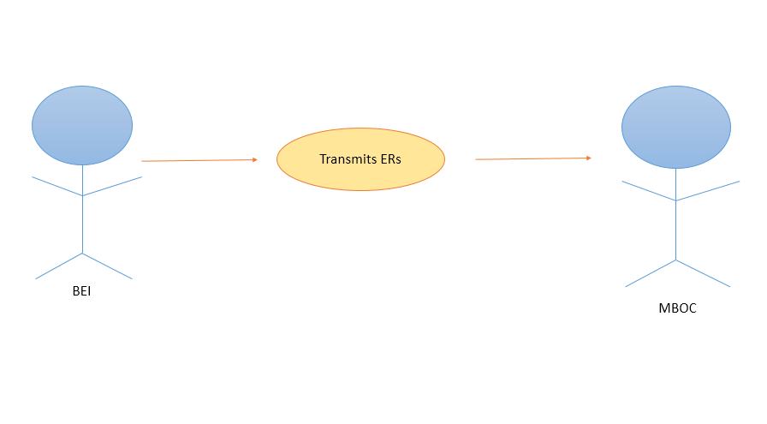

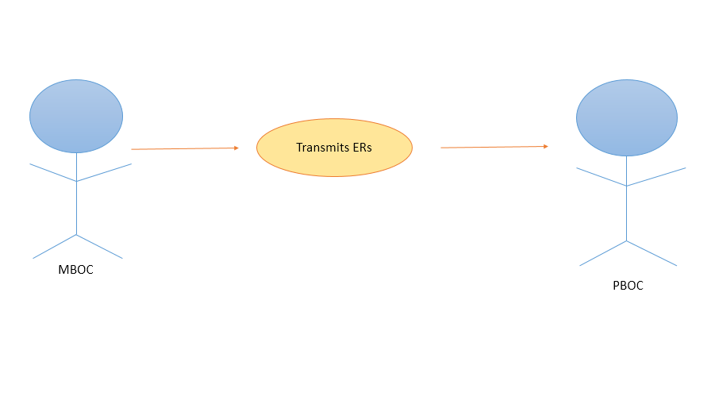

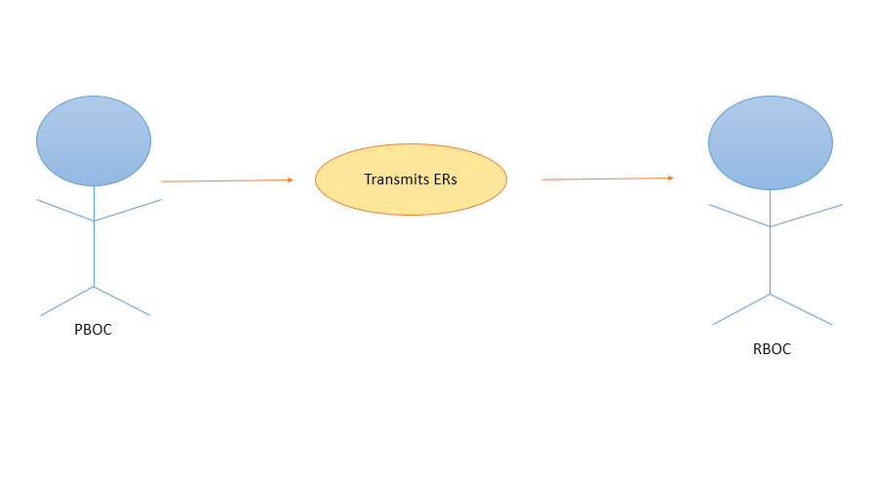

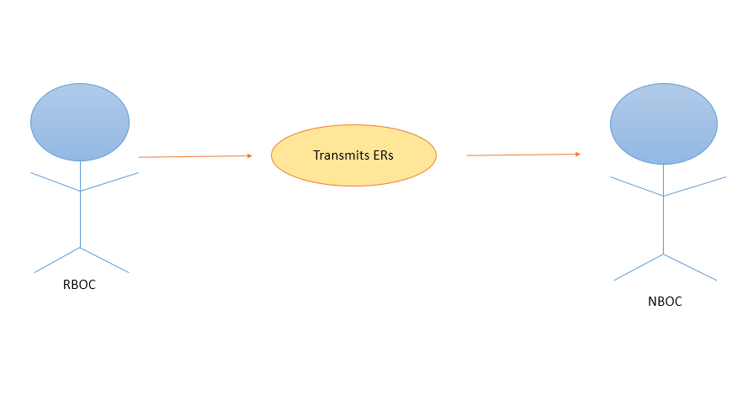

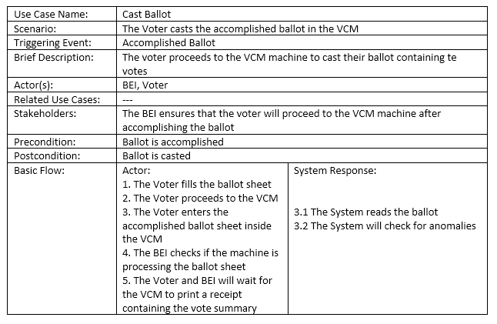

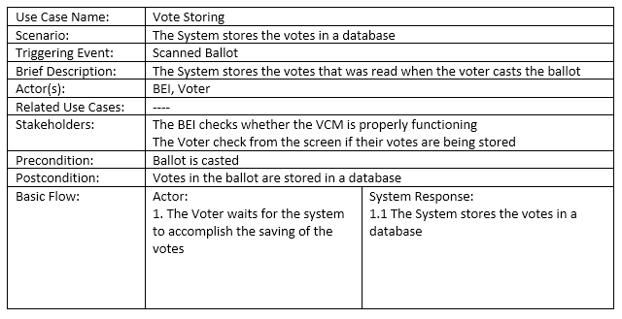

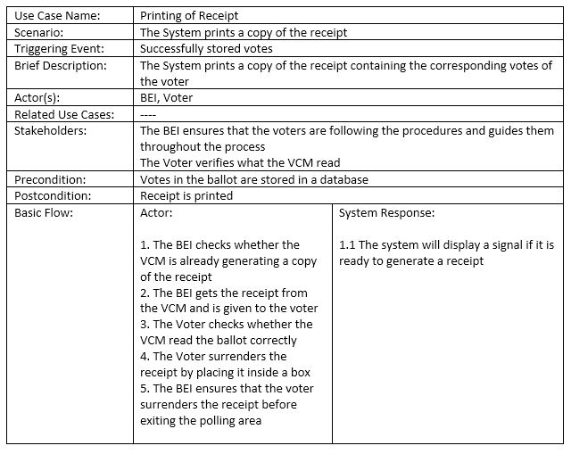

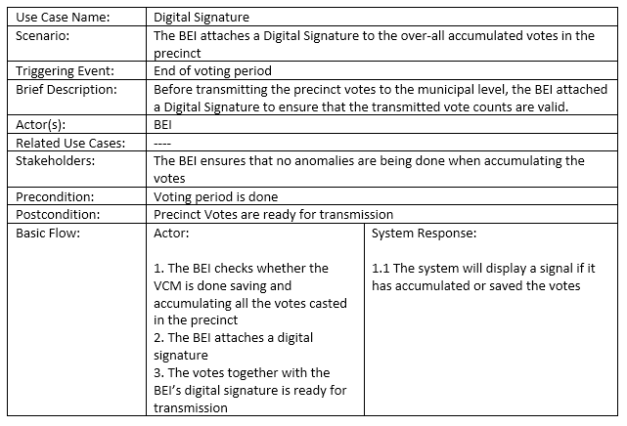

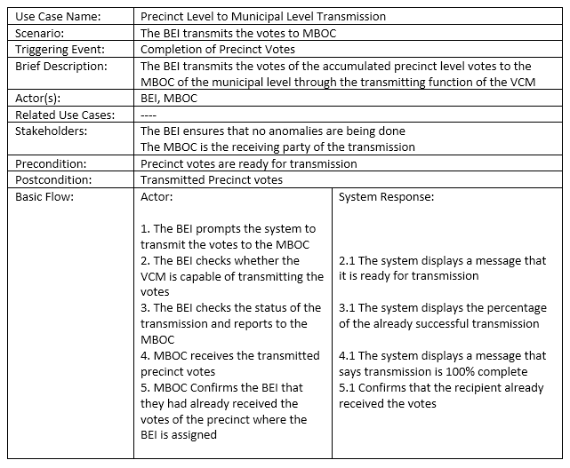

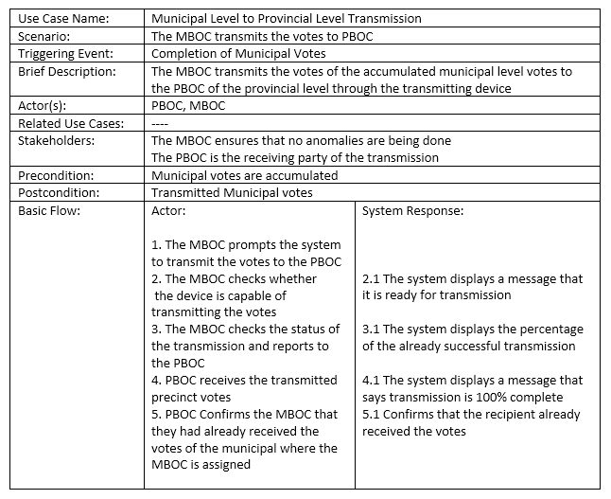

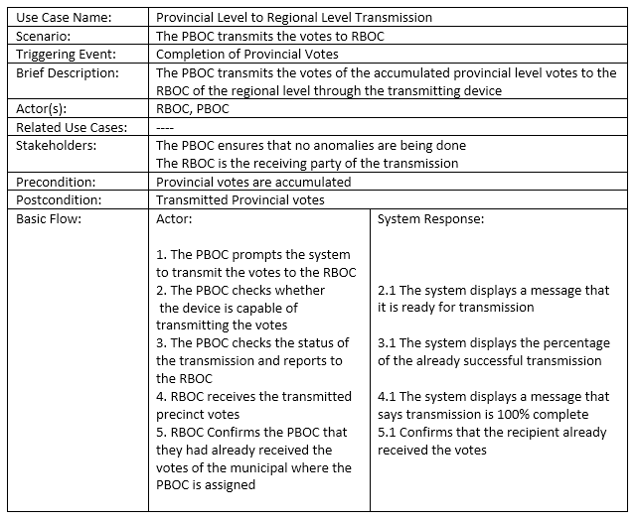

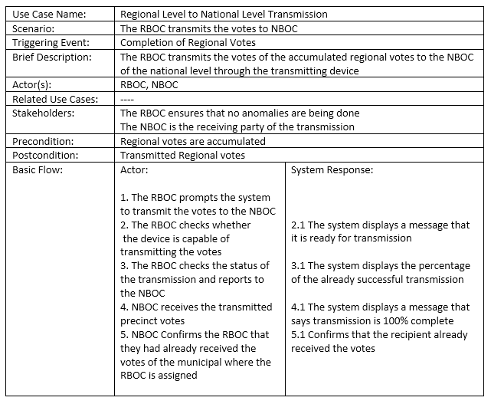

**Activity Diagram**

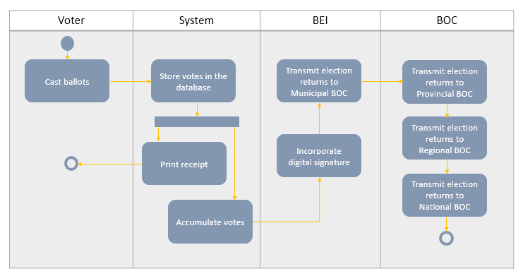

**Object Diagram**

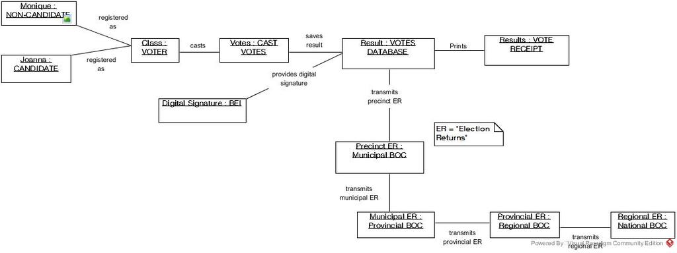

**Class Diagram**

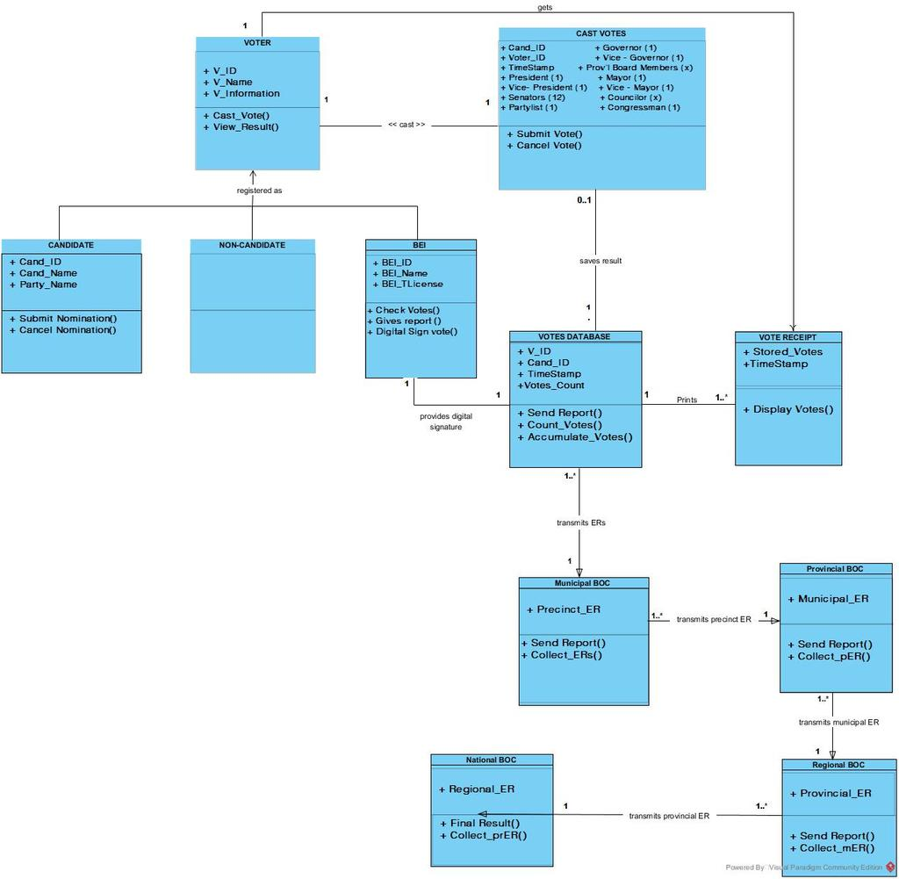

**Communication Diagram**

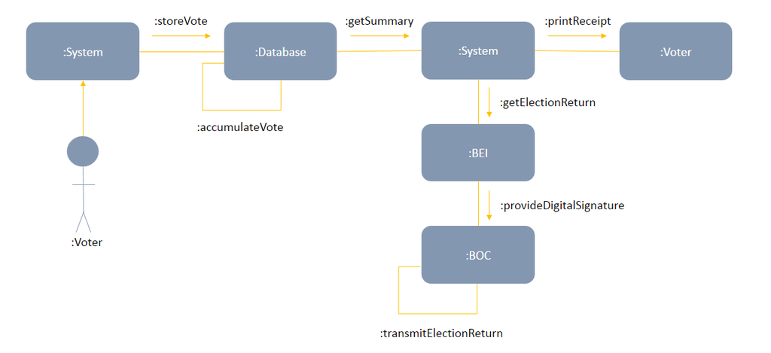

**State Diagram**

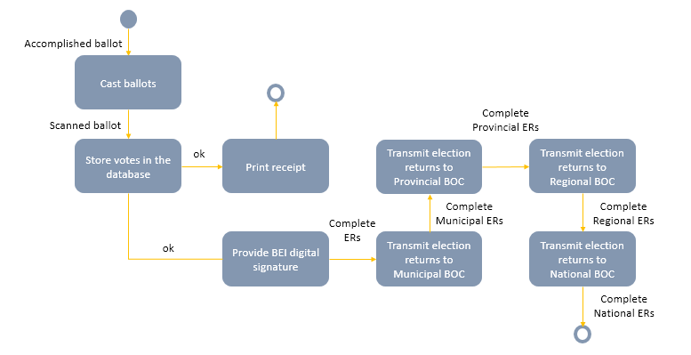

**Timing Diagram**

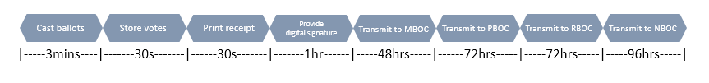

**Sequence Diagram**

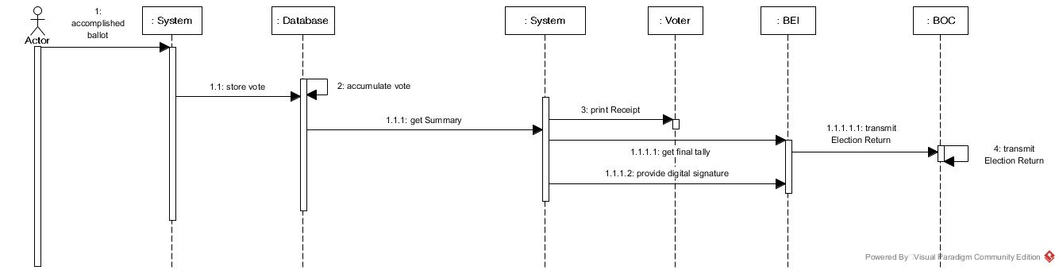

**Component Diagram**

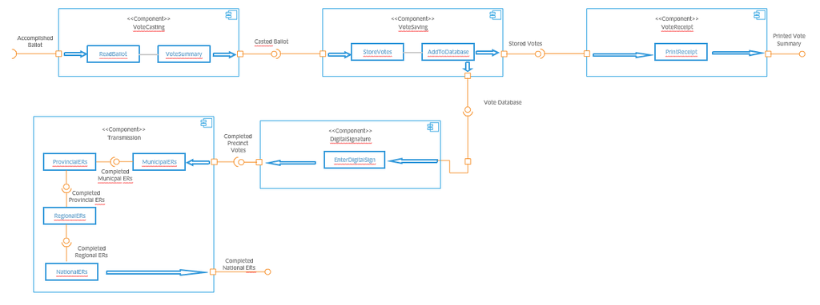

**Composite Diagram**

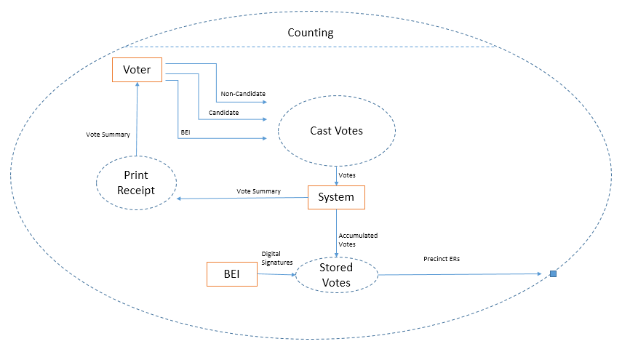

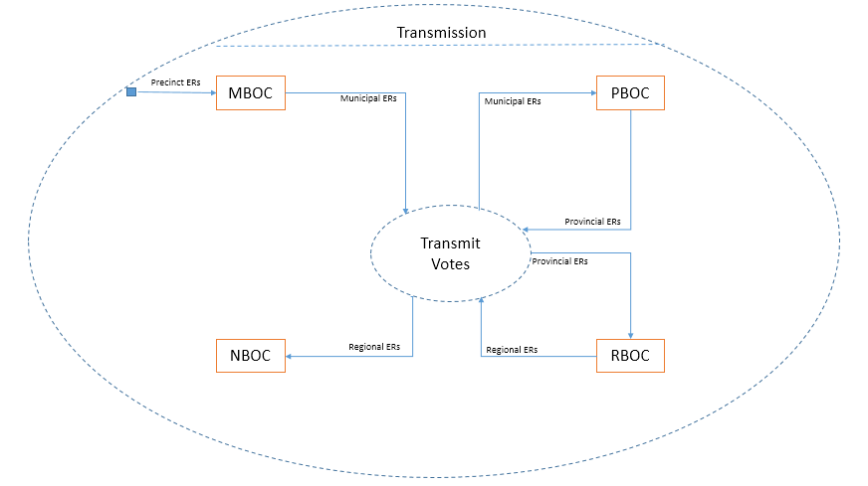

**Interaction Overview Diagram**

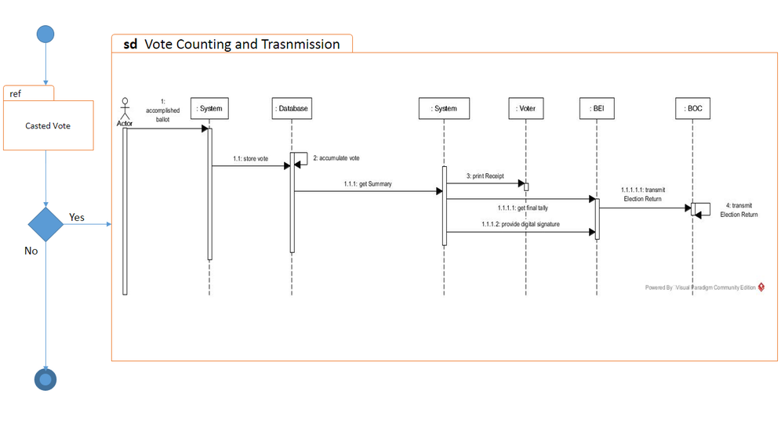

**Package Diagram**

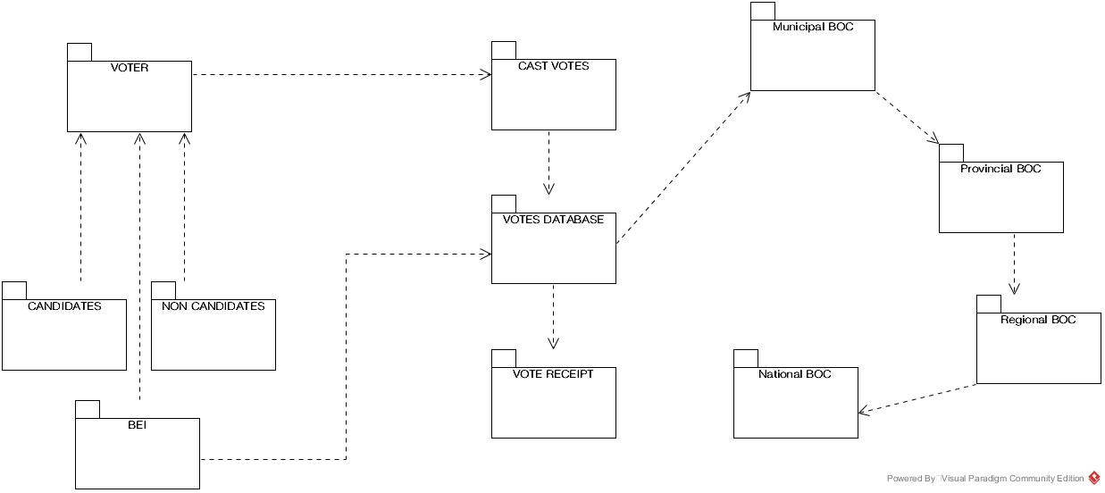

**Deployment Diagram**

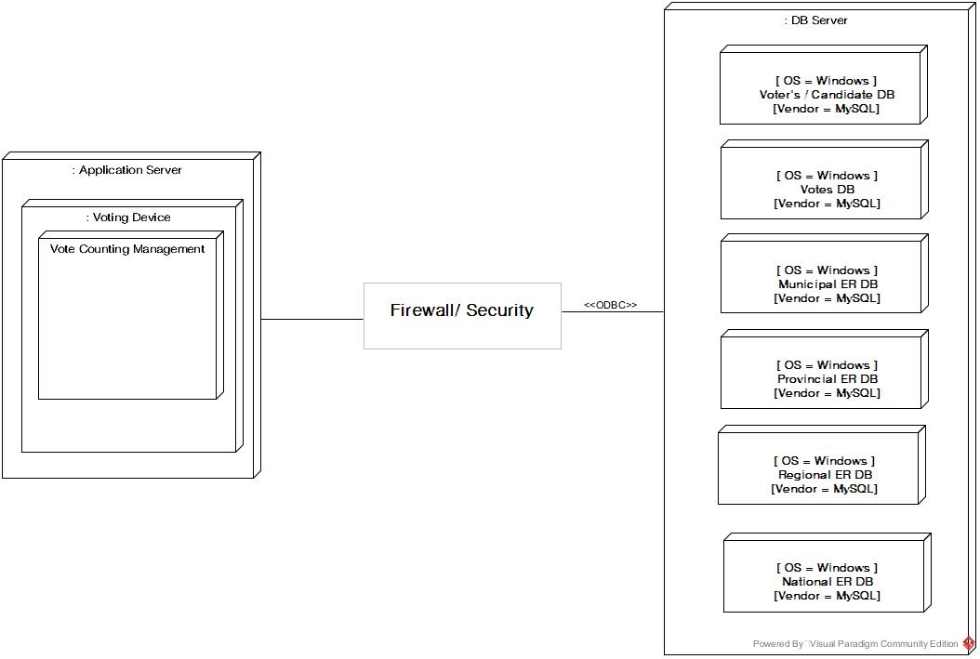

**Data Dictionary**